1. 
2. **Agenda**:
   1. We will send a bulk of events to **Elasticsearch Cluster** and
   2. Then we will visualize the data in Kibana.
3. Kibana is a Web Interface on top of Elasticsearch cluster letting us visualize and analyse its data.
4. We will not talk about how to set up Elasticsearch and Kibana and it is very easy. Attaching a link to how to install.  
   <https://www.elastic.co/downloads/>
5. 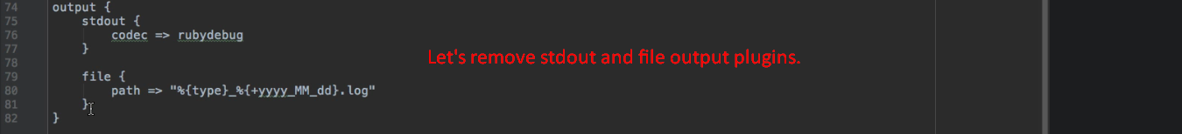
6. 
7. Skipped as discussion involved a lot about Elasticsearch even though mentor said that Elasticsearch is not part of this course and you can skip the part related to Elasticsearch in this lecture but I found so confusing and that is why skipping this lecture.